Graph sequential coloring
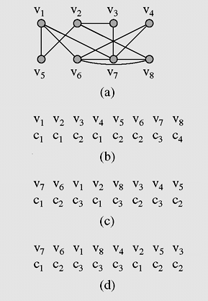

The adjacency matrix is:
 | 1 | 2 | 3 | 4 | 5 | 6 | 7 | 8
1 | 0 | 0 | 0 | 0 | 1 | 1 | 1 | 0
2 | 0 | 0 | 1 | 0 | 1 | 0 | 0 | 1
3 | 0 | 1 | 0 | 0 | 0 | 0 | 1 | 0
4 | 0 | 0 | 0 | 0 | 0 | 1 | 1 | 0
5 | 0 | 1 | 0 | 0 | 0 | 0 | 0 | 0
6 | 1 | 0 | 0 | 1 | 0 | 0 | 1 | 1
7 | 1 | 0 | 1 | 1 | 0 | 1 | 0 | 1
8 | 0 | 1 | 0 | 0 | 0 | 1 | 1 | 0

(a) A graph used for coloring.
(b) Colors assigned to vertices with the sequential coloring algorithm that orders vertices by index number.
(c) vertices are put in the largest first sequence.
(d) graph coloring obtained with the Brélaz algorithm.

